Student Rep Excellence Award
Criteria for Each Level

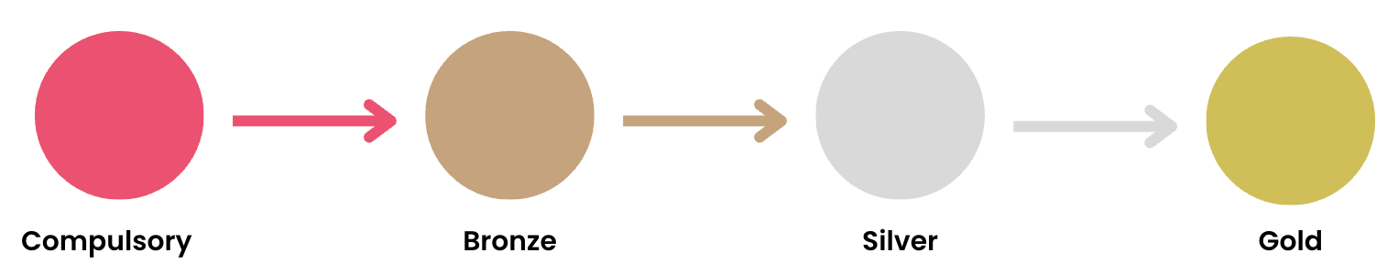

COMPULSORY
Prizes
Student Rep lanyard & e-certificate
Criteria
Complete your Student Rep Training

- Your attendance & engagement with this will be monitored & marked

This can be attended via attendance at a live session or by completing the tasks sent via email
Introduce yourself and your role to the students on your Programme and Programme Leader

- Screenshot of a message/post or equivalent
Get in touch with and follow your School Community Organisers (SCOs)

- Screenshot of an email/interaction/message or equivalent

BRONZE
Prizes
Student Rep pin badge, laptop sticker & e-certificate
Criteria
Complete the Compulsory level
Attend or provide an update at a Programme Committee Meeting (PCM)

- Send us a copy of any notes you made during (or in preparation for) the meeting, or send us a copy of the updates you provided
Nominate someone as a Student Rep or SCO of the Month

- We’ll be able to see that you’ve submitted one of these via our system
Complete a Student Feedback Form

- We’ll be able to see that you’ve submitted one of these via our system

SILVER
Prizes
Student Rep mug & e-certificate
Criteria
Complete the Bronze level
Attend Active Bystander Training

- Your attendance & engagement with this session will be monitored & marked
Complete a survey run by the SU and/or take part in a focus group

- We’ll be able to see that you’ve done one of these via our system
Attend or promote an SCO event

- We’ll be able to see if you attended via our system
- Send us any promotional images or messages you shared if you promoted the event

GOLD
Prizes
Student Rep hoodie, an endorsement on LinkedIn from the SU’s CEO & e-certificate
Criteria
Complete the Silver level
Apply for the Go Herts Award

- Send us a screenshot of an email/message/receipt or equivalent that confirms your submission
Organise an activity or meeting with other Student Reps and/or your SCOs

- Send us a screenshot of an email/message/interaction or equivalent
Join an academic society

- We’ll be able to see if you have joined one via our system
Propose or second a motion at Student Council

- We’ll be able to see if you have done this via our system

Please note that if any criteria cannot be met in full, you may still be able to achieve said level by evidencing why you feel you should to the Student Development team. Should you need to go down this route, you’ll be required to write a short statement (around 150-200 words) that outlines your reasoning.

